Exploring Cohere through Postman Collection
Chat Model (command-a-plus-05-2026)
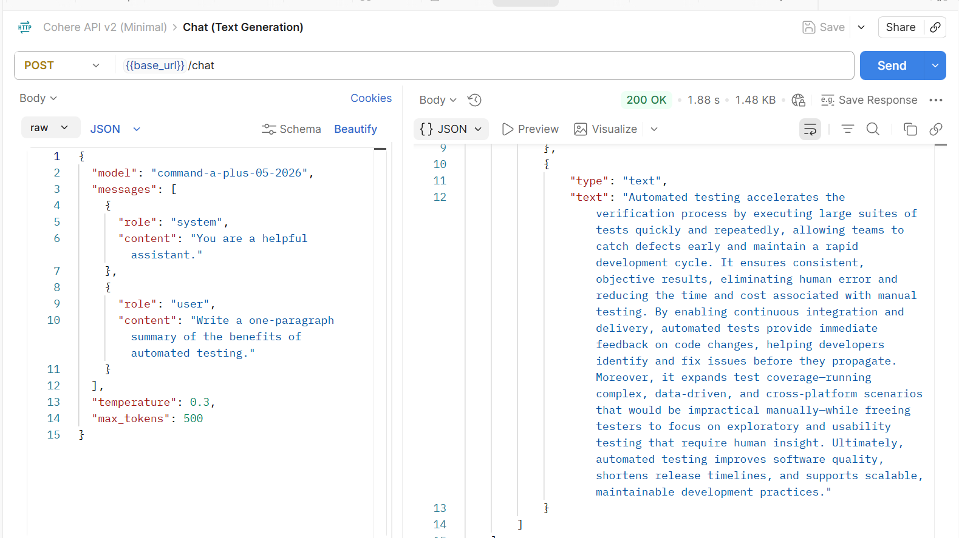

Image to Text (command-a-vision-07-2025)
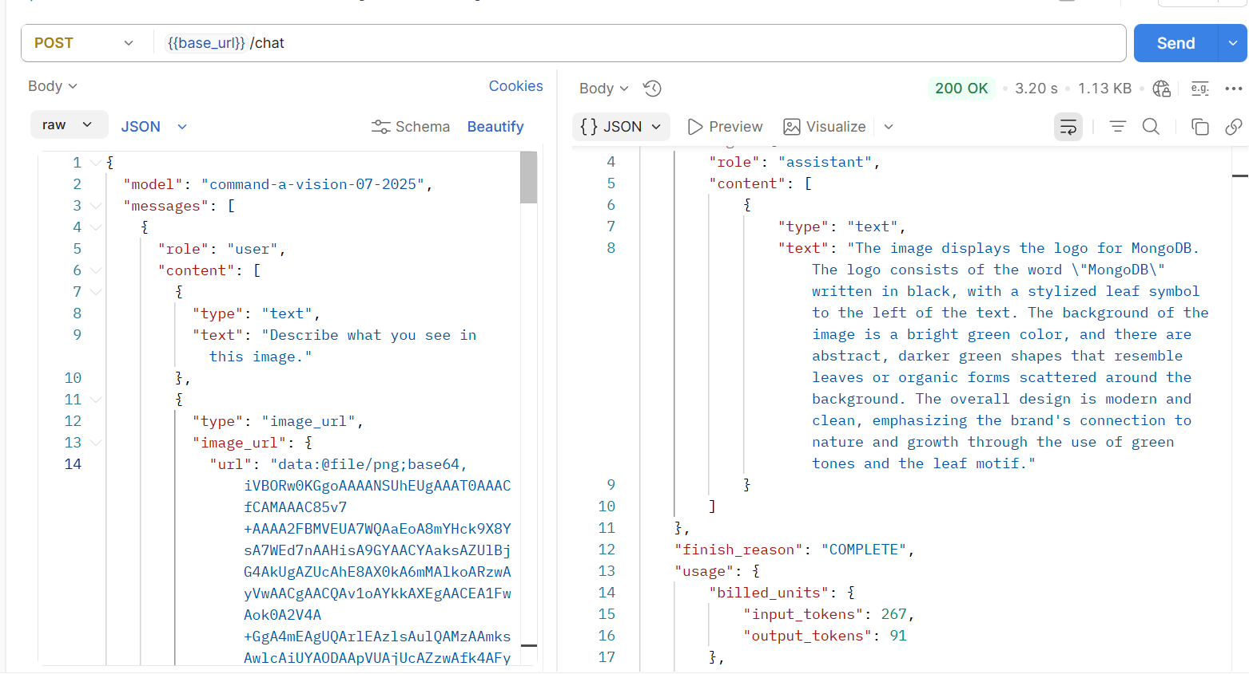

Embedding Model (embed-v4.0)
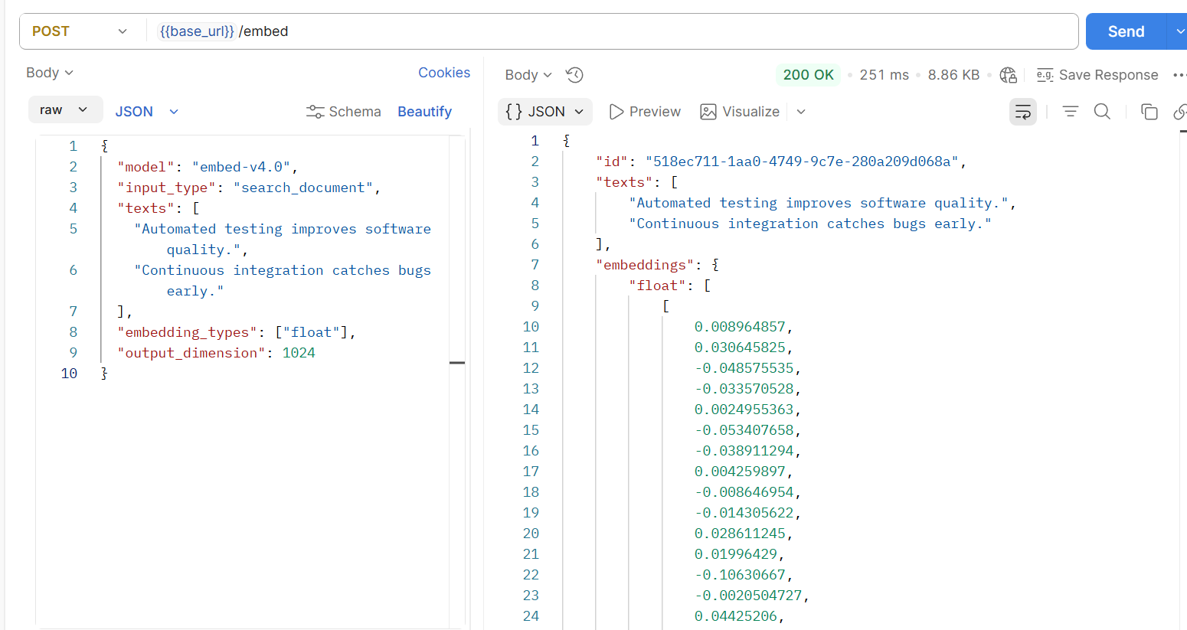

Reran Model (rerank-v3.5)

